The media's war on Clarence and Ginni Thomas
by Mark Paoletta
| February 24, 2022 11:00 PM

• • Print this article
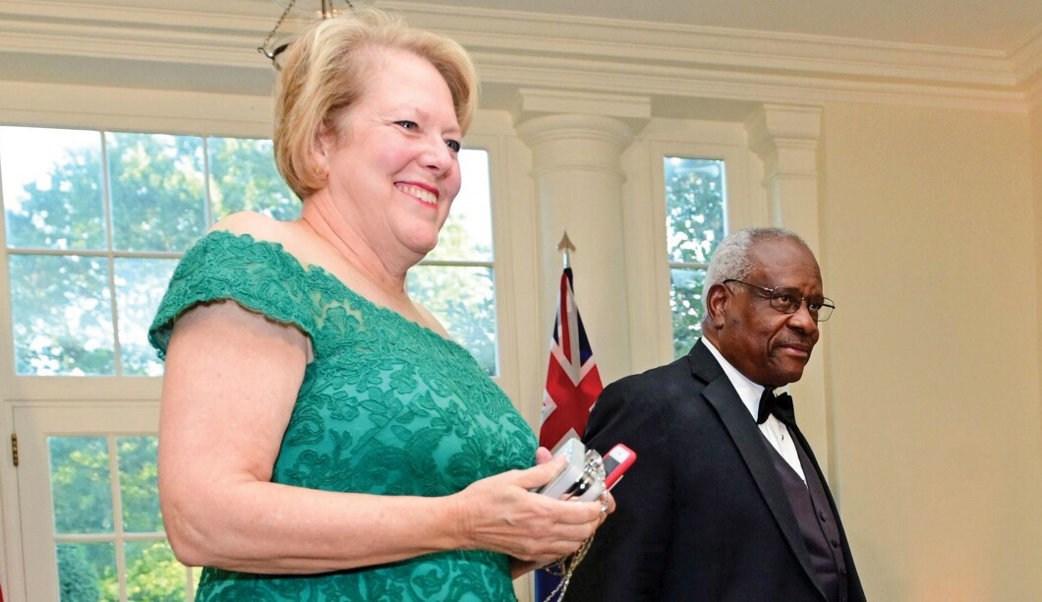

Just In...
US to provide $350 million more to Ukraine
Florida GOP advances bill regulating classroom discussion of sexual orientation
Washington Examiner's The Debrief: Jim Antle on Sen. Rick Scott’s potential GOP platform
Five times the White House said sanctions could deter Putin
A three-part plan to take Putin to task
Biden just 'reacting to Putin’s plays' as Russia mounts offensive in Ukraine
Roberts says he did not ask Gorsuch 'or any other justices' to mask up on Supreme Court bench
Biden faces questions about access and transparency ahead of press conference
For 30 years, Justice Clarence Thomas has remained unbowed by the Left’s political, and often race-based, attacks. With a growing majority of Supreme Court justices more aligned with Thomas’s jurisprudence, and with major rulings coming this spring and next term on abortion, affirmative action, and guns, the attacks on Thomas have focused on his wife, Ginni. Having failed to intimidate Thomas on his judicial opinions, the new tack is aimed at forcing his recusal from cases.
The supposed standards now being applied to Justice Thomas and his wife are either invented from whole cloth or distorted beyond recognition. The New Yorker’s Jane Mayer struck first in late January, continuing her long vendetta against Thomas, dating back to her error-filled 1994 book Strange Justice, which played on the racist tropes that Thomas was merely the black hand puppet of the white Justice Antonin Scalia. Mayer, quickly echoed by journalists from the Washington Post, CNN, the New Republic, ABC, the Nation, and just this week the New York Times, seeks to portray Ginni Thomas’s public policy work as a threat to the Supreme Court in order to pressure Thomas to recuse himself from any case that Ginni, or any of the groups she has worked with, has even commented on.
The New Republic’s Michael Tomasky, for example, wrote that because Ginni publicly opined that Obamacare was “a disaster,” Thomas was required to recuse himself from that case. Despite the fact that having a spouse with (gasp!) opinions has never been the basis for recusal by any other justice or judge, Tomasky argues that Thomas should be impeached for failing to recuse himself from cases involving Obamacare and others.
The relevant part of the judicial recusal statute requires federal judges to recuse from cases when a family member is a party to a case, when the judge knows a family member has “an interest that could be substantially affected by the outcome of a proceeding,” or when a judge’s “impartiality might reasonably be questioned.”
Ginni Thomas is a conservative activist who works to bring conservative leaders and groups together to collaborate and share information to produce effective messaging on issues of concern. It’s all coalition-building and PR. She does nothing in the legal space. At times, these groups may take public stands on matters that come before the court, or file amicus briefs (expressing the two cents of groups that are not formal parties to the case) in the Supreme Court. But none of those actions have required Thomas to recuse, and there is ample precedent for not recusing.
The Times story claims that the Thomases “have worked in tandem from the bench and the political trenches to take aim at targets” such as abortion and affirmative action, making much of the fact that they “have a shared Thomas philosophy,” quoting Justice Thomas as saying his wife is “the rock of my life” and that his brutal confirmation hearings “meld[ed] us into one being.” What should be a beautiful story about a strong marriage is turned into some kind of troubling conspiracy.
The fact that Ginni Thomas is out there in the public square should make no difference, but the Times portrays her political activism as an “unprecedented conundrum for the Supreme Court.” That’s simply not true.
The late Judge Stephen Reinhardt, for example — a liberal icon on the 9th Circuit — was married to Ramona Ripston, executive director of the ACLU of Southern California. In 2011, Reinhardt properly refused to recuse from a challenge to Proposition 8, the same-sex marriage amendment to the California Constitution. The ACLU/SC had filed an amicus brief in the lower court in that case, and his wife had spoken out on the case publicly.
Reinhardt wrote that his wife’s “views are hers, not mine, and I do not in any way condition my opinions on the positions she takes regarding any issues.” Reinhardt concluded that a reasonable person would not believe he would be partial simply because of his wife’s or her organization’s views. When Reinhardt voted exactly as his wife and the ACLU/SC had advocated, nobody accused him of being a puppet of his wife, and left-leaning members of the press applauded this working couple arrangement.
Professor Stephen Gillers, whom Mayer claims as the gold standard of judicial ethics experts, filed a brief defending Reinhardt, writing: “[A] spouse’s views and actions, however passionately held and discharged, are not imputed to her spouse, and Judge Reinhardt is not presumed to be the reservoir and carrier of his wife’s beliefs. ... A contrary outcome would deem a judge’s spouse unable to hold most any position of advocacy, creating what amounts to a marriage penalty.” This language could not be more supportive of Ginni Thomas’s right to pursue her lifetime work of public advocacy while her husband serves as a justice.
The Reinhardt/Ripston case is significantly closer to the recusal line than anything Clarence and Ginni Thomas have ever encountered. Yet in the Mayer piece, Gillers hypocritically attacks Ginni Thomas for her work.
D.C. Circuit Judge Nina Pillard likewise has sat on cases in which her husband, David Cole, the ACLU’s national legal director, has publicly advocated a specific outcome. For example, Cole praised a judge’s decision rejecting President Donald Trump’s refusal to comply with a congressional subpoena to produce his taxes. The D.C. Circuit panel affirmed this ruling, and then Judge Pillard considered whether to rehear the case en banc. Pillard voted against the rehearing, thereby allowing the decision, which her husband had supported, to stand.
Cole also wrote critically on the confinement conditions of enemy combatants held at Guantanamo Bay. Judge Pillard sat on two cases in which she voted in favor of the claims of Guantanamo detainees. Under the Left’s manufactured standard, Pillard should have recused. I am not aware of a single article that has raised concerns about Pillard not recusing from cases regarding matters on which Cole or the ACLU has commented.
Both Mayer and CNN’s Pamela Brown claim Ginni Thomas has behaved differently than other Supreme Court spouses, asserting that when Ruth Bader Ginsburg joined the D.C. Circuit in 1980, her husband, Marty Ginsburg — “one of the country’s most successful tax lawyers — left his firm and turned to teaching.” Not quite. Marty Ginsburg did indeed leave his law firm in New York, and promptly joined a major law firm, Fried Frank, in Washington, D.C. He practiced law there until he retired in February 2009.
Fried Frank filed at least three amicus briefs before the Supreme Court while Marty Ginsburg was a member of the firm, and Justice Ginsburg never recused herself. And in KSR International Co. v. Teleflex Inc. (2007), Fried Frank represented KSR, which won the case, 9-0. Justice Ginsburg did not recuse.
And if family connections or viewpoints are the concern, Jane Ginsburg, Justice Ginsburg’s daughter and a law professor, wrote an article specifically on a case pending before the Supreme Court (Aereo), and the petitioners cited her work several times. Justice Ginsburg voted consistent with what her daughter advocated, in a 6-3 opinion.
Another complaint is that Ginni Thomas’s organization gave awards to conservative leaders for their activism, some of whom subsequently filed amicus briefs with the court, and Justice Thomas did not recuse. In 1998, Justice Ginsburg donated a personally autographed copy of her VMI opinion to a fundraiser for the pro-abortion group NOW PAC. In 2004, Justice Ginsburg accepted an invitation from the pro-abortion NOW Legal Defense Fund, on whose board she had previously served, to speak in a lecture program named after Ginsburg. Two weeks earlier, she had voted in support of a NOW Legal Defense Fund amicus brief. Ginsburg rejected calls to recuse, stating there “is no one to replace us. It makes it quite important that we not lightly recuse ourselves.”
To be clear, none of these cases required recusal. But they would under the distorted recusal standards now being proposed for Justice Thomas. And wherever a genuinely fair observer might eventually draw the line, Justice Ginsburg’s various failures to recuse present far more questions than anything Ginni Thomas, a nonpracticing attorney, and Justice Thomas have done.
Meanwhile, the Nation’s Elie Mystal invents a new definition of ex parte communications to smear the Thomases, and gets his facts wrong. Mystal cites news reports of recently released emails from Ginni Thomas indicating that Justice Thomas had spoken with Florida Gov. Ron DeSantis, and Mystal then notes that Florida had sued the Biden administration over COVID mandates. According to Mystal, “legal ethics 101” holds that a judge is not allowed to speak with a litigant, without the other party present, about anything if a case is pending before a court. Nonsense. The ex parte rule forbids a judge from speaking with a litigant about the case if the other party is not present. But the notion that judges and justices can never converse ex parte with other public officials or anyone else about anything at all if they are named parties in litigation is absurd. In addition, the emails released are dated June 2021, and Florida did not file its suit until October 2021 — based on Mystal’s evidence, there was no pending case.
Ginni Thomas has worked with various groups and coalitions that have separately filed amicus briefs before the Supreme Court. Such “friends of the court” briefs provide the opinions of nonparties on issues presented in potentially precedent-setting cases. Thousands of such briefs are filed by individuals and organizations every year at the Supreme Court, with some high-profile cases netting more than 100 amicus briefs filed.
Mayer’s piece cites Democratic Sen. Sheldon Whitehouse, who has repeatedly charged that conservative justices vote in lockstep and are influenced by amicus briefs funded by dark money, that amicus briefs “are astonishingly effective in terms of the win rate.” This entire narrative is false and hypocritical. As an initial matter, amicus briefs are filed on all sides of various issues, with liberal groups being just as active as conservative groups. Furthermore, the notion that the mere expressions of opinion in amicus briefs somehow control or coerce justices is absurd. According to Paul Collins, an expert on amicus briefs whom Mayer quotes in her piece, “the influence of amicus briefs on litigation success is rather marginal.” A recent study shows that the Supreme Court cites government amicus briefs more consistently than any outside interest group. What's more damning to the Left’s false narrative is that the same study shows conservative justices cite amicus briefs the least in their opinions, and liberal justices, led by Ginsburg (over the last decade) and Elena Kagan, cite them the most. In the end, however, the influence of amicus briefs turns on the substance and persuasiveness of their content, not the identities of the amicus groups or the source of their funding.
One unsettling aspect of the current attacks on Justice Thomas is the unsubtle view that Thomas is intellectually dependent on the white people around him. Thomas is the most independent-minded justice to sit on the court, voting by himself in dissent in his first conference meeting in 1991 and persuading several other justices of his views. Thomas has written the most opinions per year of any other justice. His superb memoir, My Grandfather’s Son, makes it abundantly clear that Thomas has fiercely resisted being told what to think or do his entire life. Yet the Left persists with this racist smear.
For example, in Philip Bump’s piece in the Washington Post, he writes that “Mayer’s piece dances around the question of how much influence Ginni Thomas has over her husband,” and Bump references a quote Mayer uses from a 1991 Washington Post piece: “The one person [Clarence] really listens to is Virginia.” And then Bump adds another quote from the 1991 story: “He depends on her for advice.” Bump (and Mayer) use these quotes to imply that Thomas is dependent on Ginni’s views and opinions for his views. Similarly, in Michael Kranish’s attack on the Thomases in the Washington Post, he gleefully quotes democratic operative Mark Fabiani wondering aloud whether there is “a single opinion that Justice Thomas has ever written that is inconsistent with his wife’s far right-wing views?”
The silver lining is that, despite these attacks, Justice Thomas sits at the intellectual pinnacle of the legal world, steadfastly adhering to his originalist-based jurisprudence that the court is increasingly adopting. Thomas is training scores of clerks (130 and counting), who are taking prominent roles in the law, including numerous judgeships, and who will carry on his intellectual legacy. No doubt to the chagrin of Jane Mayer, Elie Mystal, Michael Tomasky, Michael Kranish, Philip Bump, and the other critics who invent bogus charges against him, the world is coming around to Justice Thomas’s views on the law.
After 30 years, Justice Thomas’s critics know they are not really going to intimidate him. They want to discredit him and his wife, but they also want to send a signal to the other justices, and apostate persons of color more generally, that they’ll face similarly relentless attacks. Here’s hoping that other conservatives and all independent thinkers draw strength and courage from how Justice Thomas and Ginni Thomas have never given in to intimidation.
Mark Paoletta served as a lawyer in the George H.W. Bush White House Counsel’s Office and worked on the confirmation of Justice Thomas. He most recently served as general counsel of OMB in the Trump administration. He is a partner at the law firm Schaerr Jaffe in Washington, D.C. Twitter: @MarkPaoletta.

