**Biden’s student loan pause serves progressive elite at taxpayer expense**

[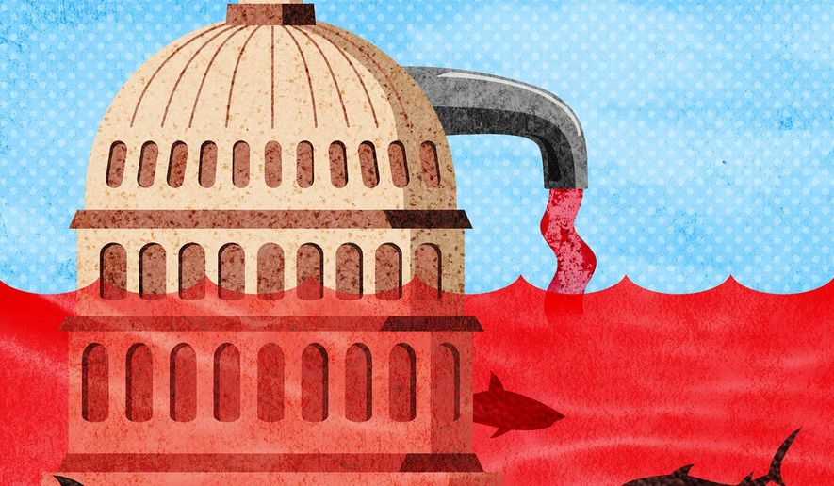](https://www.washingtontimes.com/multimedia/image/b1-mora-debt-faucetjpg/)

Biden’s student loan pause and red ink flood Illustration by Greg Groesch/The Washington Times [more >](https://www.washingtontimes.com/multimedia/image/b1-mora-debt-faucetjpg/)

[Print](javascript:window.print();)

By Isabelle Morales - - Thursday, February 24, 2022

**OPINION:**

The left claims that President Biden’s student loan moratorium is about helping the “working class.” But the moratorium is a special favor for affluent elites. It is yet another way the administration is exploiting the pandemic to push progressive policies that will harm the middle class and make out-of-control inflation worse.

Under pressure from the left, Mr. Biden announced in December that he would be extending the federal student loan repayment moratorium until May 1, 2022. This is the third extension.

The pause applies to any loan given by the federal government; this does not apply to FFEL Programs and HEAL loans that are held by commercial lenders, Perkins Loans held by schools, or any private loans.

Two weeks before the announcement, White House press secretary Jen Psaki assured Americans that the loan payments would restart in February. Instead, the administration caved to progressives who claimed that inaction would cost Democrats in the midterms.

This policy is incredibly unfair to Americans who did not rack up tens of thousands of dollars of debt. Many Americans decided against attending college, opted for less expensive schooling, served in the military to receive free education, or have worked long hours to put themselves through school instead of going into debt. This policy is also unfair to those who were proactive in paying off their debt.

Though the left claims extending the moratorium will help low-income Americans, it will actually help wealthy individuals.

The Brookings Institution described those who would benefit most from student debt forgiveness as “higher income, better educated, and more likely to be white.” The top 20% of households currently hold $3 in student loan debt for every $1 of debt held by the bottom 20% of earners. About 75% of student loan repayments come from the top 40 percent of earners, as the Committee for a Responsible Federal Budget notes.

In fact, this “issue” is hardly a low-income one at all: The median income of households making active payments on their student loans was $76,400, with just 4% of these households being below the federal poverty line.

Not only is the moratorium fundamentally unfair, but it is also a driver of new spending at a time that the U.S. has racked up trillions in new debt.

As of January, the moratorium has cost the federal government more than $100 billion. Every month, the moratorium costs the government $4 to $5 billion. This extraordinary level of spending never received Congress’ approval; instead, the president has unilaterally allocated these taxpayer dollars, constituting a blatant executive overreach.

In 2020, the U.S. government spent over $6 trillion. In 2021, the U.S. spent $6.82 trillion, or 30% of the economy. The CBO projects that U.S. interest costs will triple within the next decade — from $331 billion this year to $910 billion in 2031, accounting for 12% of the entire federal budget. In 2021, the United States’ interest payments cost roughly $2,600 per household.

This massive spending is exacerbating inflation. The federal government is flooding the economy with so much money (via handouts, subsidies or payment pauses) that demand is growing too fast for production to keep up.

Voters understand this phenomenon, as evidenced by a Harvard CAPS and Harris poll. When asked what causes inflation, the top three answers were “Massive government spending,” “Significant amounts of money being injected in the economy by the Federal Reserve,” and “Uncontrollable government deficits.”

The results of these policies are clear. In January, inflation surged to 7.5%, the highest it has been in 40 years. The average U.S. household spent $3,500 more in 2021 due to inflation, according to a Penn Wharton University of Pennsylvania Budget Model analysis.

The student loan repayment moratorium represents yet another example of Democrats using the pandemic as an excuse to implement policies that were on their agenda long before COVID-19 but were too unpopular to pass.

Democrats have also used the pandemic to transform the child tax credit into a monthly welfare payment, to expand unemployment benefits to pay people more to stay at home than to work, and to drastically expand paid sick and family leave.

The student loan repayment moratorium should end. It is not only regressive and unfair, but it has exacerbated America’s inflation problem and contributed to historic, out-of-control spending.

*• Isabelle Morales is a policy communications specialist at Americans for Tax Reform.*